**Experiment No. 6**

**RIP with 3 Router , 3 Switches and 6 PC’s:**

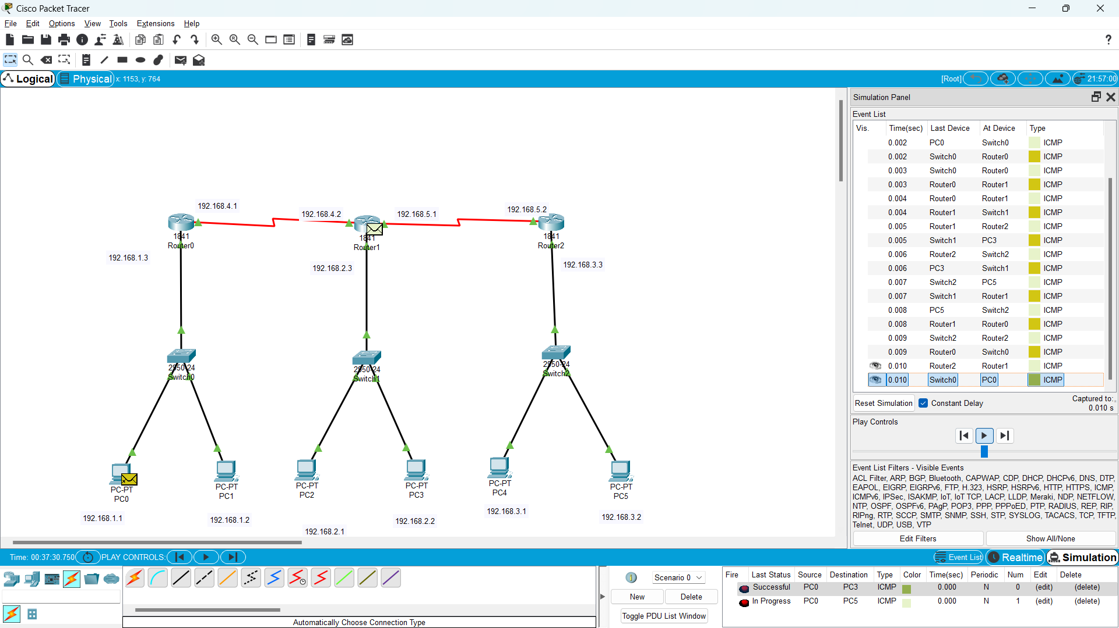

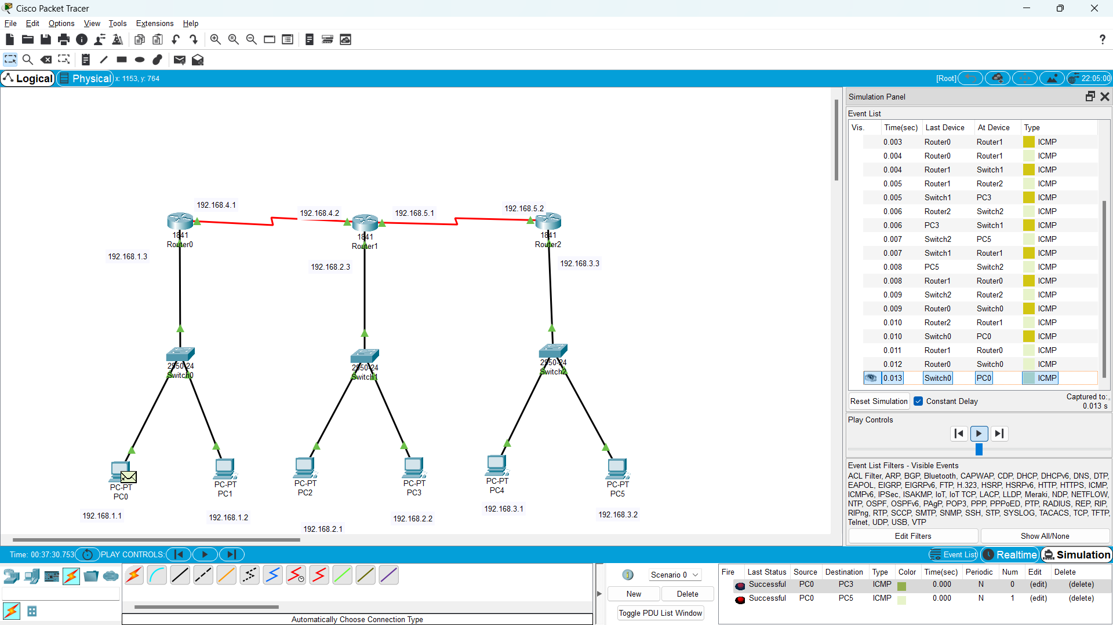Message no. 1 passed successfully

Message no. 2 passed successfully